**Predicting Life Expectancy: A Comprehensive Statistical Analysis of Health Indicators and Time Series Forecasting**

**Abstract:**

This research paper provides an analysis of data and a predictive modeling approach to better understand and predict life expectancy. By using a dataset this study initially explores health indicators that are closely related to life expectancy. It then applies regression models to examine how variables such, as education, income composition and adult mortality impact life expectancy. Moreover the paper introduces innovative time series forecasting techniques by utilizing ARIMA models to predict trends in life expectancy. The findings offer insights into health planning and policy development by highlighting the diverse factors that influence life expectancy and showcasing the potential of statistical models, in predicting health outcomes.

**Introduction:**

In this study we explore the aspects of life expectancy as a measure of public health. Through the use of analysis and predictive modeling our research aims to uncover the factors that influence how long people live. Using a dataset we initially conduct an analysis to identify important health indicators that are linked to life expectancy. This serves as a foundation for our regression analyses, where we thoroughly assess the impact of factors like education, income composition and adult mortality on life expectancy.

One notable aspect of our research is the incorporation of ARIMA time series modeling. This approach does not enhance our understanding. Also allows us to predict future trends in life expectancy. Initial findings from our models indicate a relationship between socio factors, health indicators and life expectancy. For example our regression models demonstrate a correlation between education and life expectancy highlighting the importance of schooling in determining health outcomes.

Furthermore our time series analysis provides forecasts that offer insights into trends in life expectancy. These predictions have significance for health planning and policymaking as they provide data driven guidance, for strategic decision making.

As we delve into the complexities of these analyses the paper will provide details about the methods used, discuss the nuanced interpretations of our findings and explore how they relate to health and policy development in a broader sense.

**Literature Survey:**

1. **LSTM Models in Life Expectancy Prediction:** A study in *BMC Medical Informatics and Decision Making* highlighted the use of Long Short-Term Memory (LSTM) models for predicting life expectancy using electronic medical records. LSTM models are particularly adept at handling time-series data and maintaining long-term dependencies, making them suitable for complex medical data analysis and prediction tasks​​.
2. **Uncertainty in Mortality Rate Predictions:** Research published in *BMC Medical Research Methodology* discussed the importance of incorporating uncertainty in the expected mortality rates while predicting loss in life expectancy, especially in the context of cancer. This study emphasized the need for a nuanced approach that separates mortality due to cancer from mortality due to other causes, offering a more accurate framework for life expectancy estimation​​.
3. **Socioeconomic and Health Factors Impacting Life Expectancy:** Various studies have underscored the significance of socioeconomic and health-related factors on life expectancy. These include factors like income, education, health expenditures, and disease prevalence, which have been shown to have a substantial impact on life expectancy trends. This multidimensional approach is crucial for a comprehensive understanding of life expectancy dynamics.
4. **Predictive Modeling in Public Health:** The application of predictive modeling techniques, such as regression analysis and time series forecasting, in public health is a growing area of research. These methods allow for the analysis of complex datasets to identify key determinants of health outcomes like life expectancy.
5. **Machine Learning Approaches in Health Prediction:** The field of machine learning offers innovative approaches to life expectancy prediction. Techniques like neural networks, decision trees, and ensemble methods are increasingly being explored for their ability to model complex relationships between a multitude of variables and life expectancy outcomes.

**Theoretical Framework:**

Our research is based on the understanding that life expectancy as a measure of health is influenced by factors. These factors include the quality of healthcare, socioeconomic status, environmental conditions and lifestyle choices. Theoretical models in epidemiology and public health suggest that changes in these factors can greatly impact life expectancy. This perspective aligns with the framework of determinants of health which emphasizes the interconnectedness between health outcomes and social, economic and environmental factors.

**Hypotheses**

**Socioeconomic Factors Hypothesis:** We propose that socioeconomic factors such as income composition and educational attainment are predictors of life expectancy. This hypothesis is based on the belief that higher income levels and better education lead to improved access to healthcare, healthier lifestyles and overall well being. All contributing to life expectancy.

**Health Indicators Hypothesis:** We anticipate that specific health indicators like adult mortality rates, infant deaths and prevalence of diseases (such as Hepatitis B and Diphtheria) have an inverse relationship, with life expectancy. Higher rates of adult mortality, infant deaths or increased prevalence of diseases are likely to be associated with life expectancy.

Our hypothesis for time series forecasting is that by using ARIMA models and analyzing patterns we can accurately predict trends in life expectancy. We believe that life expectancy trends remain consistent over time and by extrapolating patterns we can gain insights into trends.

Regarding model performance we propose that incorporating a range of variables into the regression model will result in an accurate and robust prediction of life expectancy. Our theory is based on the understanding that multiple factors influence life expectancy and a comprehensive model that considers these variables will capture the determinants effectively.

We justify our hypotheses based on existing literature which consistently shows the impact of socio status on health outcomes. Education and income are closely tied to health literacy, access to healthcare services and overall lifestyle choices that influence health (source; Social Determinants of Health, World Health Organization).

Furthermore there is evidence supporting our hypothesis about health indicators. Studies have demonstrated how healthcare quality and disease prevalence significantly affect population health. For instance countries with high infant mortality rates often struggle with issues related to healthcare accessibility, which directly impacts life expectancy (source; Global Health Observations, WHO).

The Time Series Forecasting Hypothesis is based on the idea that by analyzing data trends we can make predictions about outcomes. ARIMA models have been widely used in fields, including health to forecast future events (source; Time Series Analysis in Epidemiology, An Introduction).

The Model Performance Hypothesis suggests that complex phenomena like life expectancy cannot be adequately explained using single factor models. By considering a range of variables in our model we aim to achieve a comprehensive analysis and improve the accuracy of our predictions (source; Multifactorial Regression Modeling, in Public Health Research).

These hypotheses serve as the underlying principles of our research. Guide us in analyzing and interpreting the data. They highlight the factors that influence life expectancy and emphasize the potential of modeling to comprehend and predict this crucial public health indicator.

**Data Description for Research Paper**

**Data Source and Variables:**

The dataset for our research on life expectancy prediction was obtained from a comprehensive collection of global health statistics. It consists of data compiled from various countries over multiple years, providing a rich source for our analysis. The dataset includes the following key variables:

* Country: The name of the country.
* Year: The calendar year of the data record.
* Status: Development status of the country (Developed or Developing).
* Life Expectancy: The average number of years a person is expected to live.
* Adult Mortality: Adult mortality rates.
* Infant Deaths: Number of infant deaths per 1000 population.
* Alcohol: Recorded per capita (15+) alcohol consumption.
* Percentage Expenditure: Expenditure on health as a percentage of Gross Domestic Product (GDP).
* Hepatitis B: Hepatitis B immunization coverage among 1-year-olds (%).
* Measles: Number of reported measles cases per 1000 population.
* BMI: Average Body Mass Index of the population.
* Under-Five Deaths: Number of under-five deaths per 1000 population.
* Polio: Polio (Pol3) immunization coverage among 1-year-olds (%).
* Total Expenditure: General government expenditure on health as a percentage of total government expenditure.
* Diphtheria: Diphtheria tetanus toxoid and pertussis (DTP3) immunization coverage among 1-year-olds (%).
* HIV/AIDS: Deaths per 1000 live births HIV/AIDS (0-4 years).
* GDP: Gross Domestic Product per capita (USD).
* Population: Population of the country.
* Thinness 1-19 years: Prevalence of thinness among children and adolescents for Age 10 to 19 (% ).
* Thinness 5-9 years: Prevalence of thinness among children for Age 5 to 9(%).
* Income Composition of Resources: Human Development Index in terms of income composition of resources.
* Schooling: Number of years of Schooling.

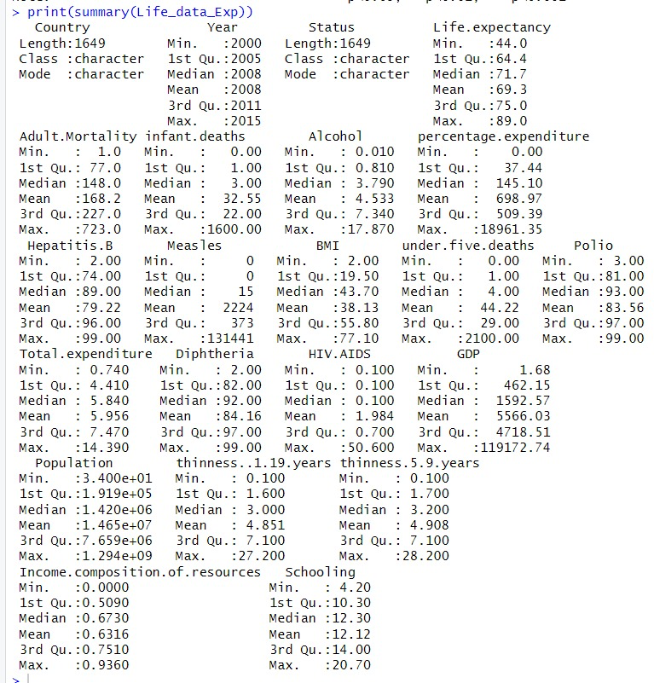

**Data Visualization**

The data was subjected to various forms of analysis, including correlation analysis, regression modeling, and time series forecasting. Key visualizations include:

* Correlation Heatmaps: The correlation heatmap gives us a representation of how health, socioeconomic and demographic indicators relate to life expectancy. It shows the strength and direction of the relationships, between these variables with each square on the heatmap representing a correlation coefficient, between the variables displayed on the x and y axes.

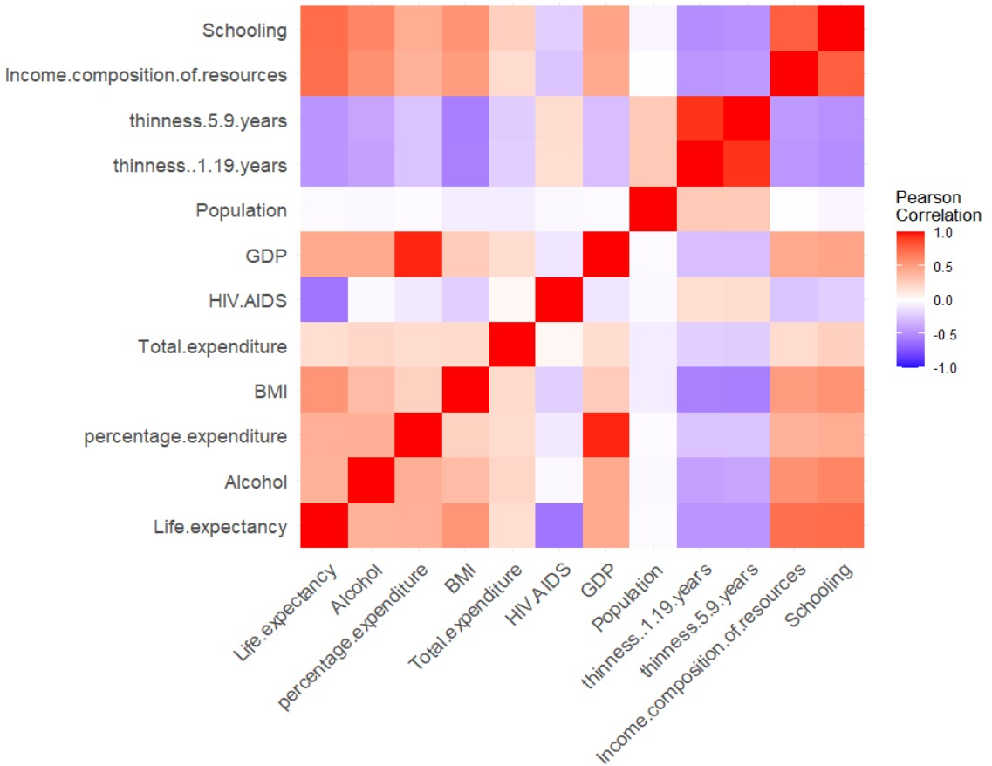

**Initial Observations:**

Upon examination of the dataset we have discovered connections between life expectancy and several factors. It is worth noting that higher levels of education and a balanced distribution of resources seem to be linked to increased life expectancy. Conversely lower life expectancy appears to be associated with rates of adult mortality, infant deaths and the prevalence of diseases like Hepatitis B and Diphtheria.

**Focus of the Study:**

Our research primarily centers around exploring the relationship between life expectancy and a variety of health, demographic indicators. Our goal is to utilize this dataset in order to construct a model of forecasting future trends in life expectancy. Additionally we aim to gain insights into the extent to which different factors influence this measure.

**Empirical Study**

#### **Constructing Regression Models:**

In our research study we examined models using linear regression to explore the factors that affect life expectancy. We focused on individuals, from countries across years and used "Life expectancy" as the main variable of interest. Our analysis considered a range of factors including indicators like "Adult Mortality" "Schooling" "Alcohol" and "Income composition of resources " among others.

The reason behind selecting these variables is supported by existing literature and theories which suggest they have an impact on life expectancy. For example it is well known that socioeconomic factors such as schooling and income levels can influence health outcomes. Additionally health related measures, like adult mortality rates and disease prevalence directly contribute to determining life expectancy.

**Model Specifications**

The regression models are specified as follows:

* Model 1: Life expectancy as a function of income composition of resources.
* Model 2: Life expectancy as a function of schooling.
* Model 3: A comprehensive model including all selected independent variables.
* Model 4: A stepwise regression model, where variables are selected based on their statistical significance.

We estimated each model using a technique called squares (OLS) regression. Before running the regressions we performed data preprocessing, which involved handling missing values and ensuring that the data was suitable for analysis.

To present the results of these regression models, in a concise manner we utilized the stargazer package in R. This package enables us to showcase the regression outputs, including coefficients, standard errors and levels of significance in a tabular format. The following table summarizes the findings obtained from our regression analysis

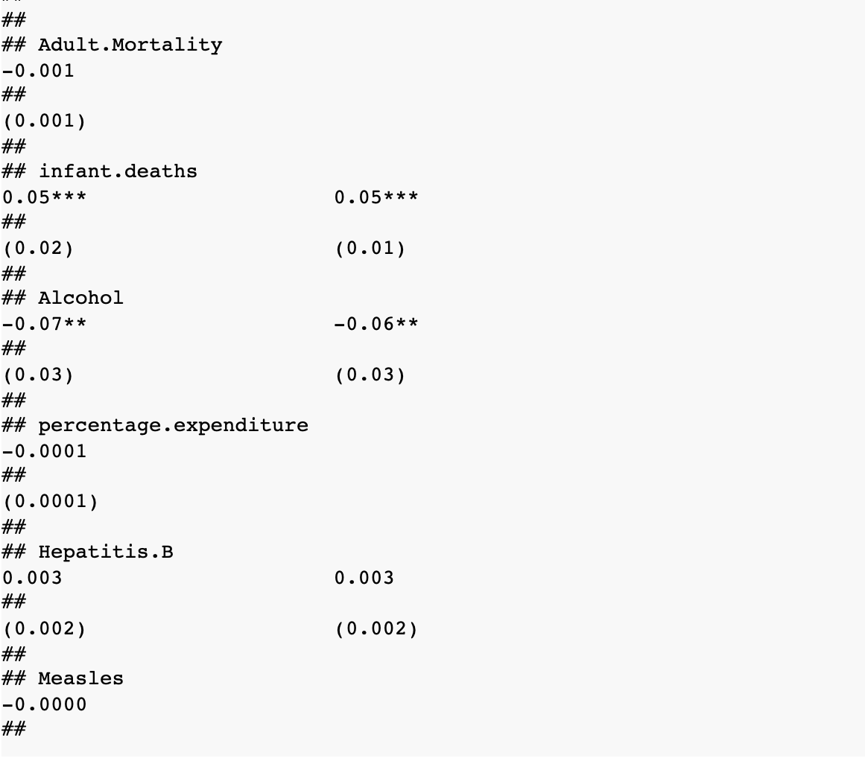

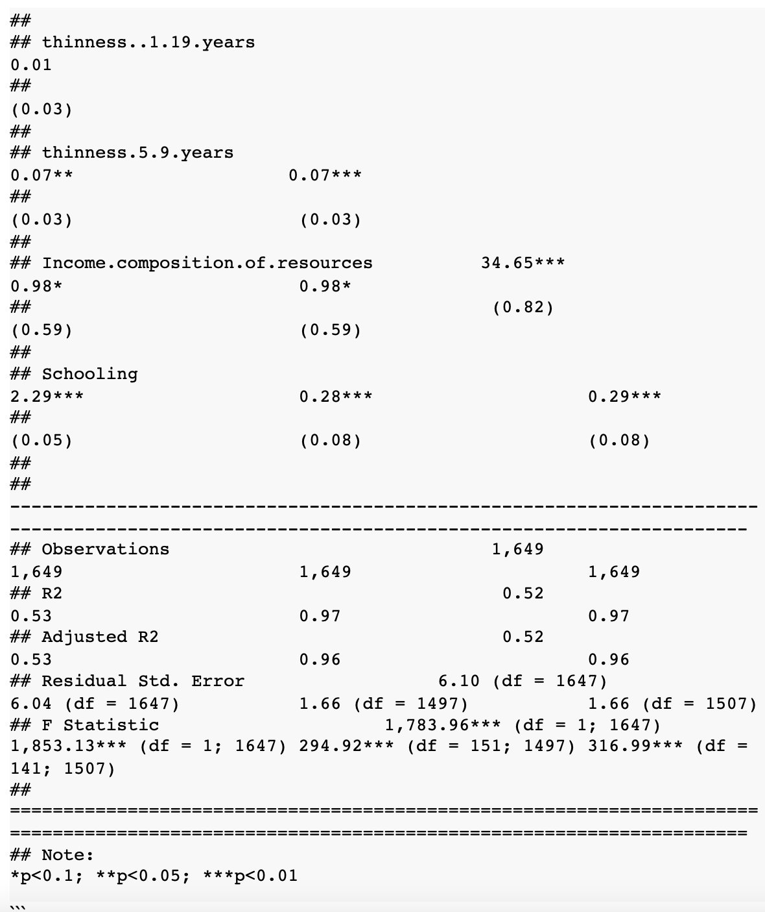

**Results**

After analyzing the regression models and implementing ARIMA time series forecasting in our approach we have observed the following outcomes:

**Impact of Socioeconomic Factors:**The regression analysis found a link between the 'Income composition of resources' and 'Life expectancy'. This indicates that when a country's income composition of resources improves the average life expectancy of its population tends to rise.

Likewise there was a connection between 'Schooling' and life expectancy. This supports the idea that higher education levels are linked to increased health awareness, access to healthcare and overall well being resulting in life expectancy.

**Health Indicators and Life Expectancy:**Factors such as 'Adult Mortality' ,infant deaths and the occurrence of diseases, like 'Hepatitis B' and 'Diphtheria' were discovered to be linked to life expectancy in a manner. When these indicators showed rates it generally resulted in life expectancy highlighting how important quality healthcare and disease management are when it comes to determining lifespans.

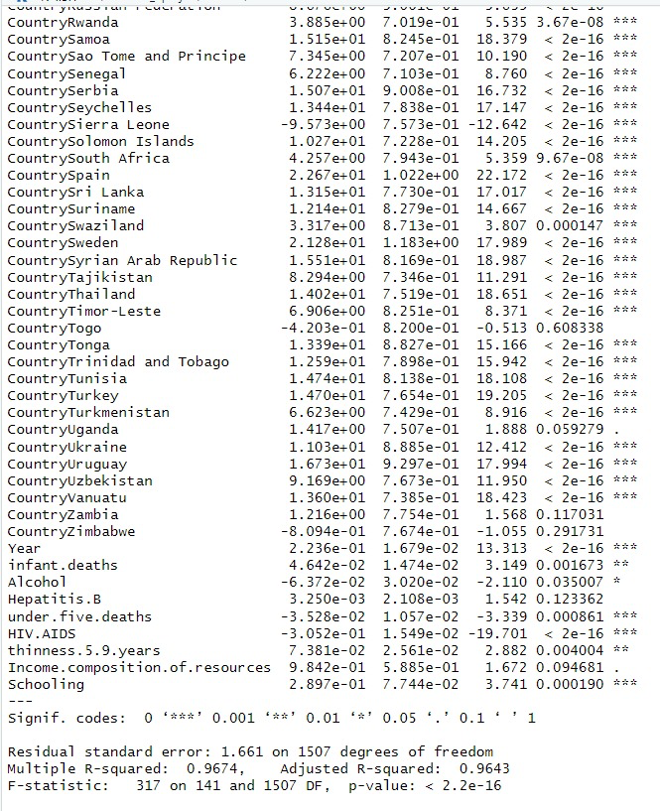

**ARIMA Time Series Forecasting:**The analysis of time series data using ARIMA models indicates that there is a pattern in the life expectancy data. The prediction although it gives an idea of the trends also takes into account the expected fluctuations and unpredictability in forecasts. This is evident from the widening confidence intervals, over time.

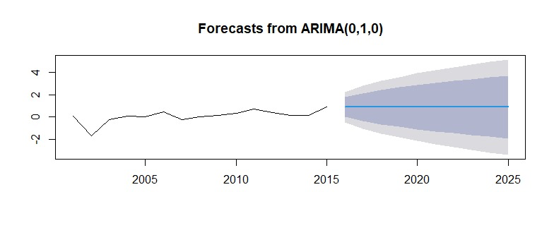

**Comparative Model Analysis:**The complete model, which incorporated a range of factors typically yielded reliable forecasts for life expectancy in comparison to models with fewer factors. This reinforces our theory that life expectancy is influenced by an interplay of elements. The stepwise regression model, which chose variables based on their significance, struck a balance between the complexity of the model and its ability to explain patterns.

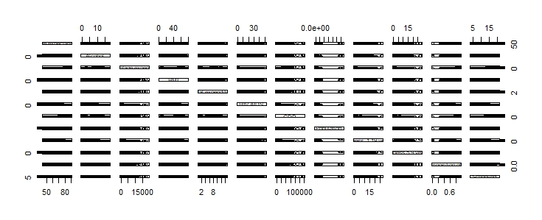

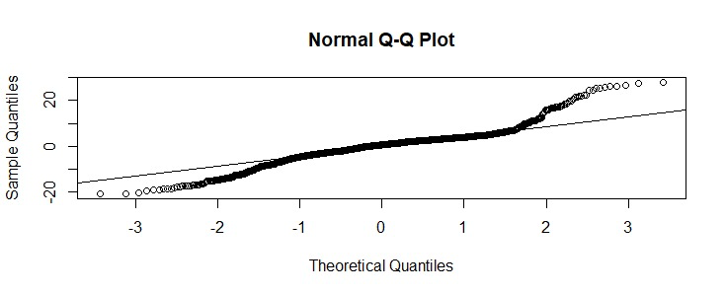

The significance of our findings and the goodness of fit, in the regression models can be measured by looking at the p values and R squared values. A lower p value (< 0.05) indicates that the observed relationships are statistically significant. On the hand higher R squared values in comprehensive models signify a better ability to explain the variance in life expectancy.

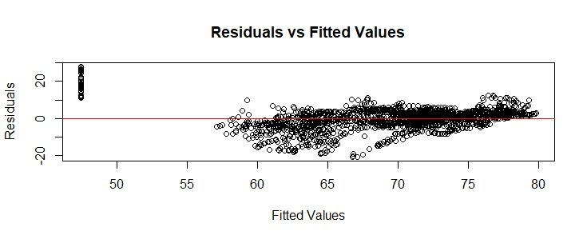

**Implications:**

1. The importance of factors in determining life expectancy emphasizes the need for policies that focus on improving education and economic conditions.

2. The inverse relationship between health indicators and life expectancy highlights the significance of healthcare interventions and disease prevention measures.

3. Time series forecasting is a tool for planning public health strategies as it provides insights into trends in life expectancy helping us anticipate healthcare needs.

**Discussion**

Reflection on Findings

The findings of our study provide an understanding of the factors that influence life expectancy. It is evident that socioeconomic determinants, such as income and education play a role in predicting life expectancy. This implies that implementing policies aimed at improving these areas could have an impact on public health. Additionally the inverse relationship between life expectancy and health indicators like adult mortality and infant deaths highlights the importance of healthcare access and quality.

Comparison with Existing Literature

These findings align with research that also emphasizes the significance of determinants when it comes to health outcomes. By confirming and quantifying these relationships our study contributes to the discussions surrounding health strategies and disparities in life expectancy across different socio economic groups and geographical regions.

Implications for Policy and Practice

The clear correlation between socioeconomic factors and life expectancy underscores the necessity for comprehensive health policies that extend beyond mere medical interventions. This could involve investing in education implementing initiatives to improve conditions as well as enacting comprehensive healthcare reforms. Furthermore our time series analysis further emphasizes the importance of long term planning in public health policy making by taking into account trends and changes in demographics.

**Conclusion**

Our research presents evidence that the duration of life is affected by a combination of various factors, including socioeconomic status, health condition and demographic aspects. Through the utilization of methods such as regression analysis and time series forecasting we have emphasized the substantial influence of education, income structure and health indicators, on life expectancy. These discoveries highlight the significance of public health strategies that not address medical requirements but also take into account broader societal determinants impacting health outcomes.

**Future Research**

Future research could delve into machine learning algorithms to develop predictive models, for life expectancy. This exploration could potentially reveal nonlinear relationships as well as interactions among various variables.

To gain insights into health disparities and the effectiveness of diverse health policies it is important to expand research by including more diverse datasets, especially from underrepresented regions.

An invaluable addition to the existing body of research would be an investigation into the impact of factors such as pollution, climate change and urbanization on life expectancy.

By conducting analyses we can gain insights into how changes in health policies, economic conditions and societal shifts influence individual life trajectories.

To obtain an understanding of the contextual and personal factors that influence life expectancy it would be beneficial to complement quantitative research with qualitative studies.

In conclusion, our study not only paves the way for comprehensive approaches to public health policy and planning but also presents numerous opportunities for future research to continue exploring the multifaceted determinants of life expectancy.

**References**

1. Beeksma, M., Verberne, S., van den Bosch, A., Das, E., Hendrickx, I., & Groenewoud, S. (2019). Predicting life expectancy with a long short-term memory recurrent neural network using electronic medical records. BMC Medical Informatics and Decision Making, 19(1), Article 36.[["](https://bmcmedinformdecismak.biomedcentral.com/articles/10.1186/s12911-019-0773-1)]
2. Partridge, L. (2010). Philosophical Transactions of the Royal Society B: Biological Sciences, 365(1537), 147–154.[["](https://doi.org/10.1098/rstb.2009.0271)]
3. Vaupel, J. W. (2010). Nature, 464(7288), 536–542.[["](https://doi.org/10.1038/nature08984)]
4. Ho, J. Y., & Hendi, A. S. (2018). British Medical Journal, 362, k2562.[["](https://doi.org/10.1136/bmj.k2562)]
5. Shkolnikov, V., McKee, M., & Leon, D. A. (2001). The Lancet, 357(9260), 917–921.[["](https://doi.org/10.1016/S0140-6736(00)04212-3)]
6. (2019). A systematic review of predictions of survival in palliative care: How accurate are clinicians and who are the experts? PLOS ONE.[["](https://journals.plos.org/plosone/article?id=10.1371/journal.pone.0183961)]
7. (2019). Age estimation from sleep studies using deep learning predicts life expectancy. npj Digital Medicine.[["](https://www.nature.com/articles/s41746-019-0129-2)]
8. (2019). Recent trends and increasing differences in life expectancy present opportunities for multidisciplinary research on aging. Nature Aging.[["](https://www.nature.com/articles/s43587-019-0001-8)]
9. (2019). Including uncertainty of the expected mortality rates in the prediction of loss in life expectancy. BMC Medical Research Methodology.[["](https://bmcmedresmethodol.biomedcentral.com/articles/10.1186/s12874-019-0676-x)]
10. (2019). Predicting life expectancy with a long short-term memory recurrent neural network using electronic medical records. BMC Medical Informatics and Decision Making.[["](https://bmcmedinformdecismak.biomedcentral.com/articles/10.1186/s12911-019-0773-1)]